***SDLC Assignment Questions***

### **1. Introduction to SDLC:**

* **Q1:** What is the Software Development Life Cycle (SDLC)? Explain why SDLC is important in software development.

The **Software Development Life Cycle (SDLC)** is a structured process used for developing software applications. It breaks down the software development process into distinct stages, ensuring systematic progress and predictable outcomes. These stages typically include **Requirement Gathering, Design, Development, Testing, Deployment, and Maintenance**.

**Importance of SDLC:**

* **Improved Planning:** SDLC helps establish a roadmap for the project, ensuring tasks are well-organized and prioritized.
* **Reduced Risks:** Identifying risks early reduces costly errors during later stages.
* **Higher Quality:** Each phase focuses on delivering a quality product by addressing specific goals and verifying progress.
* **Predictable Timeline:** SDLC provides a clear timeline, improving stakeholder confidence.
* **Efficient Resource Use:** Allocates resources effectively at each phase.
* **Q2:** List and describe the different phases of the SDLC. How does each phase contribute to the overall software development process?

1. **Requirement Gathering:**
   * Activities: Identify and document functional (e.g., features) and non-functional (e.g., performance, security) requirements.
   * Contribution: Ensures all stakeholders’ expectations are aligned to avoid costly misunderstandings.
2. **Design:**
   * Activities: Develop the system's architecture, database schema, and user interfaces.
   * Contribution: Lays a blueprint for development, reducing ambiguities.
   * Types:
     + **High-Level Design (HLD):** Focuses on overall system architecture.
     + **Low-Level Design (LLD):** Focuses on detailed implementation at the module level.
3. **Development (Coding):**
   * Activities: Write, compile, and integrate code based on the design.
   * Contribution: Converts abstract designs into functional software.
4. **Testing:**
   * Activities: Verify the system meets requirements through testing techniques like unit, integration, and system testing.
   * Contribution: Detects and resolves bugs to ensure software reliability.
5. **Deployment:**
   * Activities: Release the software into the live environment, including data migration and setup.
   * Contribution: Delivers the product to users while ensuring a smooth transition.
6. **Maintenance:**
   * Activities: Update software to fix issues, enhance performance, or adapt to changing user needs.
   * Contribution: Ensures long-term usability and relevance of the software.

* **Q3:** Explain the difference between **Waterfall Model**, **Agile Model**, and **V-Model**. In which situations would each model be most appropriate?

1 **Waterfall Model:**

* **Description:** Linear and sequential model where each phase must be completed before moving to the next.
* **Advantages:**
  + Simple and easy to understand.
  + Works well for projects with fixed requirements.
* **Disadvantages:**
  + Difficult to accommodate changes.
  + Late detection of defects.
* **Best For:** Projects with clear, stable requirements, such as government or legal applications.

2 **Agile Model:**

* **Description:** Iterative approach that delivers software in small increments, with frequent feedback and adjustments.
* **Advantages:**
  + Highly flexible and adaptable to changes.
  + Frequent releases ensure quick feedback.
* **Disadvantages:**
  + Requires high collaboration.
  + May lack clear documentation.
* **Best For:** Dynamic projects, such as mobile apps or customer-driven applications.

3 **V-Model:**

* **Description:** Extension of the Waterfall model with a focus on validation and verification, where each development phase has a corresponding testing phase.
* **Advantages:**
  + Emphasizes quality with early testing.
  + Clear deliverables at each stage.
* **Disadvantages:**
  + Inflexible to changes.
  + Testing depends on well-documented requirements.
* **Best For:** Safety-critical systems, such as medical devices or aerospace software.

### **2. SDLC Phases and their Importance:**

* **Q4:** Describe the **Requirement Gathering** phase of the SDLC. What methods are used to gather requirements from stakeholders?

• **Description:**  
In this phase, the project team identifies and documents what the stakeholders need from the software. It includes defining the system's functional, non-functional, and business requirements.

• **Methods Used:**

* **Interviews:** One-on-one discussions with stakeholders.
* **Surveys/Questionnaires:** Collecting data from a large group of users.
* **Workshops:** Collaborative sessions with stakeholders.
* **Observation:** Watching users interact with existing systems.
* **Document Analysis:** Studying current systems and documentation.
* **Q5:** In the **Design** phase, what are the key activities involved? Differentiate between high-level design and low-level design.

**Key Activities in the Design Phase**:

1. **Requirement Analysis**: Translate requirements into technical solutions.
2. **Architectural Design**: Define system architecture, components, and technologies.
3. **Data Design**: Develop database schemas and data flow diagrams.
4. **Interface Design**: Plan user interfaces and interactions.
5. **Documentation**: Create design documents for future reference.

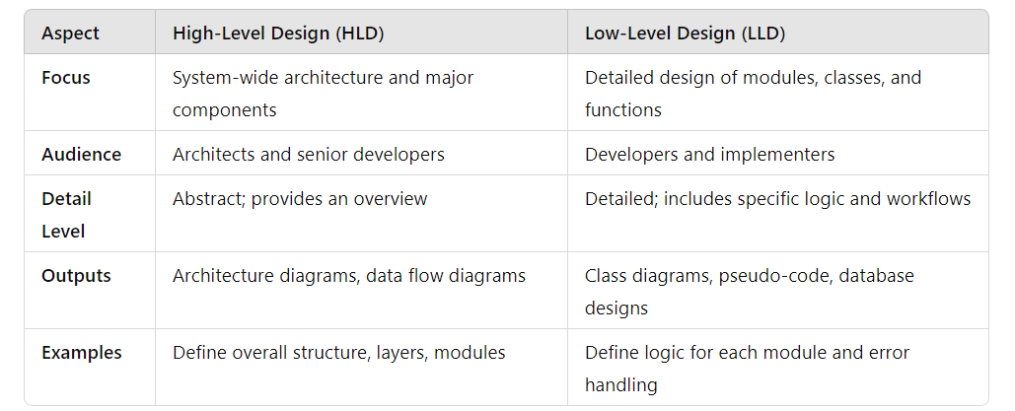

* **Q6:** Explain the **Coding** or **Development** phase of the SDLC. What tools and techniques are typically used by developers during this phase?

->The Coding or Development phase is where the design is translated into executable software. Developers write, review, and manage the codebase based on design documents and project requirements.

**Tools and Techniques**:

1. **Version Control**: Git, GitHub, GitLab, or Bitbucket.
2. **Integrated Development Environment (IDE)**: IntelliJ IDEA, Visual Studio, Eclipse.
3. **Programming Languages**: Depends on the project (e.g., Java, Python, C#, JavaScript).
4. **Code Review Tools**: SonarQube, Crucible.
5. **Testing Frameworks**: JUnit, Selenium, Postman.
6. **Build Tools**: Maven, Gradle, Jenkins for CI/CD.

**Key Activities**:

* Writing and optimizing code.
* Ensuring adherence to coding standards.
* Conducting peer reviews.
* Integrating modules.
* **Q7:** What is the importance of the **Testing** phase in SDLC? Explain the different types of testing that are performed during this phase (e.g., unit testing, integration testing, system testing).

The Testing phase ensures the software meets quality standards and functions as intended. It identifies and resolves bugs, improving user satisfaction and reliability.

**Types of Testing**:

1. **Unit Testing**:
   * Focus: Test individual components or modules.
   * Tools: JUnit, NUnit.
   * Example: Testing a login function independently.
2. **Integration Testing**:
   * Focus: Test the interaction between modules.
   * Tools: Postman, SoapUI.
   * Example: Testing user authentication with the database.
3. **System Testing**:
   * Focus: Test the complete system for compliance with requirements.
   * Tools: Selenium, QTP.
   * Example: Testing the entire e-commerce application.
4. **Acceptance Testing**:
   * Focus: Verify the system meets end-user requirements.
   * Tools: Manual testing or specific tools like TestRail.
   * Example: End-users test features before launch.
5. **Performance Testing**:
   * Focus: Assess speed, scalability, and stability.
   * Tools: JMeter, LoadRunner.

* **Q8:** Describe the **Deployment** phase in the SDLC. What are the key considerations for successfully deploying software into a live environment?

The Deployment phase involves delivering the software to the production environment for users. It requires coordination, planning, and monitoring.

**Key Considerations**:

1. **Environment Setup**:
   * Ensure servers, databases, and networks are ready.
2. **Version Control**:
   * Use CI/CD pipelines for streamlined deployment.
3. **Rollback Plan**:
   * Prepare for potential deployment failures.
4. **User Training**:
   * Provide necessary training or documentation.
5. **Monitoring**:
   * Use tools like Nagios, New Relic, or Splunk to monitor software.

**Deployment Strategies**:

* **Big Bang Deployment**: All features released simultaneously.
* **Phased Deployment**: Release in stages.
* **Blue-Green Deployment**: Alternate between two identical environments.
* **Canary Deployment**: Gradual release to a small user segment.
* **Q9:** What happens during the **Maintenance** phase? Why is it important for the long-term success of the software?

The Maintenance phase ensures the software continues to operate efficiently post-deployment. It involves bug fixes, updates, and system enhancements.

**Key Activities**:

1. **Bug Fixing**: Address issues reported by users.
2. **Updates and Upgrades**: Implement new features or improve existing ones.
3. **Performance Optimization**: Ensure software scalability and speed.
4. **Security Management**: Patch vulnerabilities and update protocols.
5. **User Support**: Provide assistance to resolve user queries.

**Importance**:

1. **Longevity**: Keeps the software relevant and functional over time.
2. **User Satisfaction**: Maintains a positive user experience.
3. **Compliance**: Ensures the software aligns with evolving regulations.
4. **Adaptability**: Accommodates new business needs or technologies.

### **3. Models in SDLC:**

* **Q10:** What is the **Waterfall Model**? List its advantages and disadvantages. In which scenarios is it most effective?

The Waterfall Model is a linear and sequential software development methodology where each phase must be completed before the next begins. It follows a top-down approach, making it easy to understand and manage.

**Phases in the Waterfall Model**:

1. **Requirement Analysis**
2. **System Design**
3. **Implementation (Coding)**
4. **Testing**
5. **Deployment**
6. **Maintenance**

**Advantages**:

1. **Simplicity**: Easy to understand and implement.
2. **Structured Approach**: Well-defined stages make project tracking straightforward.
3. **Documentation**: Comprehensive documentation in every phase.
4. **Clear Deliverables**: Clear outputs for each phase.
5. **Suitable for Small Projects**: Works well for small, well-defined projects.

**Disadvantages**:

1. **Inflexibility**: Changes in requirements are difficult to accommodate.
2. **Late Testing**: Testing occurs only after development, increasing the risk of finding major defects late in the cycle.
3. **High Risk**: If an error is made early, it can propagate through the stages.
4. **Not Ideal for Complex Projects**: Ineffective when requirements are unclear or subject to change.
5. **Customer Feedback**: Limited involvement of stakeholders after the requirements phase.

**Most Effective Scenarios**:

1. **Small Projects**: With clear and fixed requirements.
2. **Stable Requirements**: When requirements are unlikely to change.
3. **Regulatory Compliance**: Projects where extensive documentation is required.
4. **Hardware-Software Integration**: Systems needing significant hardware integration.

* **Q11:** Explain the **Agile Model** in SDLC. How does it differ from the Waterfall model, and what are its key principles?

The Agile Model is an iterative and incremental software development approach emphasizing collaboration, adaptability, and rapid delivery. It is designed to accommodate changing requirements and stakeholder involvement throughout the project.

**Key Principles of Agile**:

1. **Customer Collaboration**: Continuous interaction with stakeholders.
2. **Adaptive Planning**: Plans are flexible and evolve as the project progresses.
3. **Incremental Delivery**: Software is delivered in small, usable segments.
4. **Cross-Functional Teams**: Collaboration between diverse roles within the team.
5. **Continuous Improvement**: Feedback-driven iterations to improve quality.
6. **Focus on Value**: Prioritize delivering functional software.

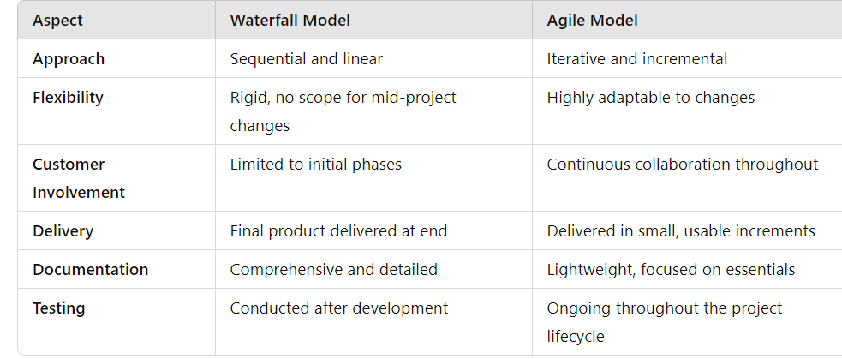

**Advantages of Agile**:

1. **Flexibility**: Adapts to changing requirements effectively.
2. **Customer Satisfaction**: Frequent deliveries keep stakeholders engaged.
3. **Early Detection of Issues**: Continuous testing minimizes defects.
4. **Improved Team Collaboration**: Encourages open communication and teamwork.
5. **Quick Delivery**: Reduces time to market with incremental releases.

**Disadvantages of Agile**:

1. **Less Predictability**: Hard to estimate time and cost for complex projects.
2. **Requires Skilled Teams**: Success depends on team expertise and collaboration.
3. **Limited Documentation**: Can lead to confusion in future maintenance.
4. **Stakeholder Dependency**: Needs active and frequent involvement from stakeholders.

**Best Scenarios for Agile**:

1. **Dynamic Requirements**: Projects where requirements frequently evolve.
2. **Complex Projects**: Large projects requiring regular feedback.
3. **Innovation-Oriented Projects**: When flexibility and experimentation are necessary.
4. **Customer-Centric Development**: Projects demanding regular stakeholder input.

4o

### **4. Real-World Applications and Scenarios:**

* **Q12:** Imagine you are working in a team developing a banking application. Discuss how you would follow the SDLC in your project, focusing on each phase.

**1. Requirement Analysis**:

* **Activities**: Gather and analyze requirements, ensuring compliance with financial regulations. Identify features such as account management, fund transfers, loan applications, and security measures.
* **Deliverables**: Requirements specification document.

**2. System Design**:

* **Activities**: Create architectural diagrams, design databases for secure and efficient transaction handling, and define system interfaces.
* **Deliverables**: High-Level Design (HLD) for overall architecture and Low-Level Design (LLD) for individual modules.

**3. Development**:

* **Activities**:
  + Implement code for modules such as user authentication, transaction processing, and reporting.
  + Use secure coding practices to protect sensitive data.
* **Tools**: Java, Spring Boot, MySQL, Git.

**4. Testing**:

* **Activities**: Conduct unit, integration, system, and security testing. Simulate real-world scenarios such as high transaction volumes and potential hacking attempts.
* **Deliverables**: Bug reports, test case documents.

**5. Deployment**:

* **Activities**: Deploy the application on production servers while ensuring compliance with banking standards.
* **Key Considerations**: Data migration, server configurations, and rollback mechanisms.

**6. Maintenance**:

* **Activities**: Address user-reported bugs, implement regulatory updates, and enhance features.
* **Tools**: Monitoring tools like New Relic for performance and logs.
* **Q13:** You are tasked with developing a mobile app for a fitness tracking company. Create a brief SDLC plan for this project, detailing each phase and the activities involved.

**1. Requirement Analysis**:

* **Activities**: Identify core features like activity tracking, calorie counting, progress monitoring, and user engagement through notifications.
* **Output**: Functional requirements document.

**2. System Design**:

* **Activities**:
  + Design app architecture (client-server model).
  + Plan database for user data and activity logs.
* **Output**: UI/UX mockups, API design, database schema.

**3. Development**:

* **Activities**:
  + Build frontend in Flutter or React Native.
  + Implement backend APIs using Spring Boot.
  + Integrate wearable device data.
* **Tools**: Android Studio, Xcode, Postman.

**4. Testing**:

* **Activities**:
  + Test features like step counting, syncing, and notifications.
  + Perform compatibility testing across devices.
* **Tools**: Appium, Espresso.

**5. Deployment**:

* **Activities**: Publish the app to the Google Play Store and Apple App Store. Ensure proper app signing and meet platform guidelines.
* **Key Considerations**: Gradual rollout and user feedback collection.

**6. Maintenance**:

* **Activities**: Add new features like diet tracking, fix bugs, and optimize performance based on analytics.
* **Tools**: Firebase for crash analytics.
* **Q14:** In a software development project, the project manager has opted to use the **Agile Model**. How will this affect the roles of the development team and the way the project is managed?

**1. Development Team**:

* **Increased Collaboration**: Teams work closely with stakeholders and testers throughout the process.
* **Frequent Deliverables**: Develop and deliver features in sprints (2–4 weeks).
* **Flexibility**: Adapt to changing requirements quickly.

**2. Project Management**:

* **Dynamic Planning**: Plans are updated regularly based on sprint outcomes and feedback.
* **Role of Scrum Master**: Facilitates daily stand-ups, sprint planning, and retrospectives.
* **Stakeholder Involvement**: Continuous feedback and prioritization ensure alignment with business goals.

**Key Difference**: Agile promotes a decentralized approach where teams self-organize, as opposed to the structured hierarchy of the Waterfall Model.

* **Q15:** How would you approach testing in a project that uses the **Waterfall Model**? Compare this with testing in an **Agile Model** project.

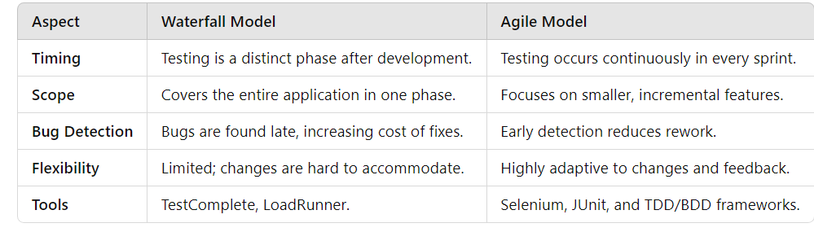

* **Q16:** Discuss the challenges you might face in the **Deployment** phase of the SDLC when moving from a development environment to a production environment. How would you overcome these challenges?

• **Environment Differences**: Configuration mismatches between development and production.

* **Solution**: Use containerization tools like Docker for consistent environments.

• **Downtime**: Disruptions during deployment.

* **Solution**: Use zero-downtime strategies like Blue-Green Deployment.

• **Data Migration**: Ensuring data integrity during migration.

* **Solution**: Perform backups and test migrations in a staging environment.

• **Security**: Exposing the application to real-world threats.

* **Solution**: Conduct thorough penetration testing and use secure deployment pipelines.

• **Rollbacks**: Difficulty in reverting to the previous state.

* **Solution**: Implement automated rollback mechanisms in CI/CD pipelines.

• **User Acceptance**: Issues not anticipated during testing.

* **Solution**: Use phased or canary deployment to gather real-time feedback.

### **5. SDLC Documentation:**

* **Q17:** Create a sample **Test Plan** document for a simple web application. List the key components that should be included in the plan.

**1. Test Plan Identifier**

* **Document Name**: Test Plan for Simple Web Application
* **Version**: 1.0
* **Prepared By**: QA Team

**2. Introduction**

* This document outlines the strategy, objectives, and schedule for testing the web application.
* **Scope**: Functional testing, UI/UX testing, and performance testing for a web application with user registration, login, and dashboard functionality.

**3. Objectives**

* Ensure all functionalities meet the requirements.
* Verify the application is user-friendly and performs efficiently.

**4. Test Items**

* Modules to be tested:
  1. **User Registration**
  2. **User Login**
  3. **Dashboard**

**5. Features to Be Tested**

* Registration form validations.
* Login authentication (valid and invalid scenarios).
* Dashboard data display.

**6. Features Not to Be Tested**

* Backend database performance tuning.
* Non-core features like optional user settings.

**7. Test Approach**

* **Types of Testing**:
  + Unit Testing.
  + Functional Testing.
  + Compatibility Testing (browser/device).
  + Performance Testing.

**8. Pass/Fail Criteria**

* Test cases pass if the expected and actual results match.
* Test cases fail if discrepancies are found or critical bugs occur.

**9. Test Deliverables**

* Test case document.
* Bug reports with severity and priority levels.
* Final test summary report.

**10. Test Environment**

* Browsers: Chrome, Firefox, Safari.
* Devices: Windows 10 PC, macOS, and Android/iOS smartphones.
* Tools: Selenium for automation, JMeter for performance testing.

**11. Schedule**

* **Phase 1**: Test case design and review - Week 1.
* **Phase 2**: Functional testing - Week 2.
* **Phase 3**: Performance and compatibility testing - Week 3.

**12. Roles and Responsibilities**

* **QA Lead**: Oversee test execution and ensure deadlines.
* **Testers**: Execute test cases and report issues.

**13. Risks and Contingencies**

* **Risk**: Delays in test environment setup.
* **Contingency**: Use cloud-based environments if local setup fails.

**14. Approval**

* Document signed off by Project Manager and QA Lead.
* **Q18:** As a project manager, how would you ensure proper documentation is maintained throughout the SDLC? Discuss tools that can be used for documentation management.

**1. Key Practices**

* **Standardized Templates**: Use consistent formats for requirements, design, testing, and deployment documents.
* **Version Control**: Track changes and revisions to ensure traceability.
* **Regular Updates**: Update documents at each phase to reflect changes in requirements, design, and implementation.
* **Stakeholder Reviews**: Periodic reviews by stakeholders to validate and approve documents.

**2. Tools for Documentation Management**

1. **Confluence**:
   * For collaborative documentation and knowledge sharing.
   * Ideal for maintaining project wikis, meeting notes, and requirements.
2. **Google Workspace**:
   * For creating and sharing documents, spreadsheets, and presentations.
   * Supports real-time collaboration.
3. **Microsoft SharePoint**:
   * Centralized platform for document storage and version control.
   * Includes workflows for document approval.
4. **Jira**:
   * Links requirements and test cases to issues.
   * Helps track documentation related to specific tasks or features.
5. **GitHub/GitLab Wikis**:
   * For storing and managing technical documentation.
   * Integrated with version control systems for developers.
6. **Doxygen**:
   * For generating technical documentation directly from code comments.
   * Useful in documenting APIs and libraries.

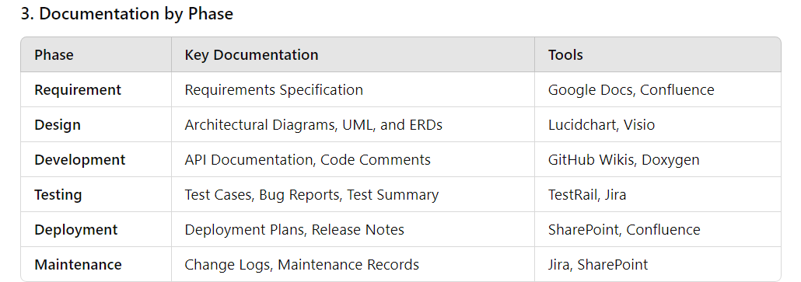

**4. Periodic Audits**  
Conduct regular audits to ensure documents are up-to-date and aligned with the project scope.

### **6. SDLC in Agile:**

* **Q19:** Create a simple **user story** for an e-commerce website project. Explain how this story fits into the **Agile** development cycle.

**User Story Title**: **"Add Items to Cart"**

**As a** customer,  
**I want** to add products to my shopping cart,  
**so that** I can review and purchase them in one transaction.

**Acceptance Criteria**

1. The customer can click an "Add to Cart" button on the product page.
2. A confirmation message appears after adding an item.
3. The cart icon updates to reflect the total number of items added.
4. The customer can view a list of all added items in the cart, along with their total price.
5. The system prevents duplicate items unless explicitly allowed (e.g., for quantity selection).

**Tasks for the User Story**

1. **Frontend Development**
   * Design the "Add to Cart" button and confirmation message.
   * Update the cart icon dynamically.
2. **Backend Development**
   * Create an API endpoint to handle adding items to the cart.
   * Store cart data in the database with user-session tracking.
3. **Testing**
   * Write unit tests for the backend API.
   * Perform UI testing for adding and displaying cart items.
   * Conduct integration testing to ensure cart updates reflect correctly.

**How This Fits Into the Agile Development Cycle**

1. **Backlog Grooming**
   * The Product Owner adds the user story to the product backlog.
   * The team reviews the story, confirms its clarity, and estimates the effort required.
2. **Sprint Planning**
   * The team prioritizes the story for the upcoming sprint based on its importance.
   * Tasks are broken down and assigned to team members.
3. **Implementation in the Sprint**
   * Developers and designers work iteratively to complete the tasks associated with the story.
   * Daily stand-ups keep the team aligned on progress and blockers.
4. **Review and Testing**
   * The feature is tested thoroughly during the sprint.
   * Feedback is incorporated, and any bugs are fixed.
5. **Sprint Review**
   * The "Add to Cart" feature is demonstrated to stakeholders.
   * Stakeholders provide feedback for potential improvements or changes.
6. **Release**
   * The story is marked as "Done" and included in the next release.
   * Users receive the new functionality, enabling them to add items to the cart.
7. **Continuous Feedback and Iteration**
   * Based on user feedback post-release, the feature may be enhanced in future sprints.

This iterative and incremental approach ensures the story is delivered efficiently while maintaining flexibility for refinements.

### **7. Quality Assurance and Testing in SDLC:**

* **Q20:** Write a **Test Case** for a login page on a website. Include the steps, expected results, and pass/fail criteria.

**Test Case: Login Page Functionality**

**Test Case ID**: TC_LOGIN_001  
**Test Case Title**: Validate User Login with Correct Credentials  
**Module**: User Authentication  
**Priority**: High  
**Test Type**: Functional Test  
**Precondition**:

* User is registered on the website with valid credentials.
* The login page is accessible.

**Test Steps**

| **Step No.** | **Description** |
| --- | --- |
| 1 | Navigate to the login page of the website. |
| 2 | Enter a valid username/email in the username/email field. |
| 3 | Enter the correct password associated with the username/email. |
| 4 | Click on the "Login" button. |

**Expected Results**

1. The user is successfully authenticated.
2. The system redirects the user to the homepage/dashboard.
3. A welcome message or the user's name is displayed on the landing page.

**Pass/Fail Criteria**

* **Pass**: The user is redirected to the homepage/dashboard with the expected welcome message.
* **Fail**:
  + The user remains on the login page with an error message indicating the issue (e.g., incorrect password).
  + No redirection occurs.

**Additional Test Scenarios**

1. **Invalid Credentials**:  
   **Steps**: Enter incorrect username or password.  
   **Expected Result**: Display an error message: "Invalid username or password."
2. **Empty Fields**:  
   **Steps**: Click "Login" without entering any credentials.  
   **Expected Result**: Display an error message: "Username and password are required."
3. **Password Visibility Toggle**:  
   **Steps**: Enter password and toggle the "Show Password" icon.  
   **Expected Result**: Password becomes visible in the field.
4. **Account Lockout**:  
   **Steps**: Enter incorrect credentials more than the allowed number of attempts.  
   **Expected Result**: Display an error message: "Your account has been locked due to multiple failed attempts. Please reset your password or contact support."
5. **Remember Me Functionality**:  
   **Steps**: Check the "Remember Me" box before logging in and close/reopen the browser.  
   **Expected Result**: The user remains logged in after reopening the browser.

These test cases ensure comprehensive coverage of the login functionality.

### **8. Risk Management in SDLC:**

* **Q21:** During the **Testing** phase, your team discovers a critical bug that requires significant changes to the design. How would you handle this issue, considering the SDLC process?

Discovering a critical bug during the **Testing phase** that impacts the design necessitates careful handling to ensure the project remains on track. Here's a structured approach:

**1. Analyze the Bug**

* **Assess Severity**: Determine the bug's criticality and its impact on the system.
* **Root Cause Analysis**: Identify the underlying cause of the bug. Engage the testing, development, and design teams to pinpoint the issue.

**2. Communicate with Stakeholders**

* **Notify Key Stakeholders**: Inform the project manager, product owner, and other relevant stakeholders about the bug.
* **Discuss Impact**: Explain how the bug affects functionality, timelines, and potential downstream processes.
* **Update Risk Management**: Revise the risk register to reflect this new issue.

**3. Initiate Design Review and Change Management**

* **Engage the Design Team**: Collaborate with the design team to evaluate the required changes.
* **Update Requirements**: If necessary, revisit the requirements phase to ensure the new design aligns with user needs.
* **Document Changes**: Record all modifications in the design documents and version control system.

**4. Revise the Project Plan**

* **Update Timeline**: Adjust the project schedule to accommodate the redesign, reimplementation, and retesting phases.
* **Reallocate Resources**: Assign additional resources if needed to expedite the process.

**5. Implement the Design Changes**

* **Iterative Design**: Redesign the affected components while keeping scalability and future-proofing in mind.
* **Develop and Integrate**: Implement the updated design and integrate it into the application.

**6. Conduct Rigorous Testing**

* **Retest the Affected Areas**: Perform regression testing to verify that the bug is resolved.
* **End-to-End Testing**: Ensure the updated design does not introduce new issues or affect other functionalities.

**7. Communicate Progress**

* **Frequent Updates**: Provide regular status updates to stakeholders about progress, challenges, and changes to the timeline.
* **Stakeholder Approvals**: Get sign-off for the updated design and testing results before proceeding further.

**8. Learn and Adapt**

* **Post-Mortem Analysis**: Conduct a retrospective to understand why the bug was not identified earlier.
* **Process Improvement**: Update the SDLC process to prevent similar issues, such as improving design reviews or testing coverage during earlier phases.

**Key Considerations in SDLC Context**

1. **Iterative Models**: If using Agile or iterative methodologies, handle the issue within the scope of the current sprint or by creating a new sprint.
2. **Waterfall Model**: If using Waterfall, this may require going back to the **Design phase**, potentially impacting project deadlines.
3. **Documentation**: Ensure all changes are well-documented to maintain traceability.

By following this structured approach, the team can minimize disruptions and ensure the project delivers a high-quality product despite the setback.

### **9. Continuous Integration and Continuous Deployment (CI/CD):**

* **Q22:** Implement a simple **CI/CD pipeline** for a sample web application. Explain the stages involved, from code commit to deployment.

**1. Tools Required**

* **Source Control**: Git (e.g., GitHub, GitLab, Bitbucket)
* **CI/CD Tool**: Jenkins, GitHub Actions, or GitLab CI/CD
* **Build Tool**: Maven, Gradle, or npm
* **Containerization**: Docker
* **Deployment**: AWS, Azure, or Kubernetes
* **Testing Framework**: JUnit, Selenium, or Jest

**Pipeline Stages**

**1. Code Commit**

* **Process**: Developers push code changes to a version control repository (e.g., GitHub).
* **Trigger**: Code commit triggers a webhook to start the CI/CD pipeline.

**2. Build Stage**

* **Purpose**: Ensure the application compiles correctly and dependencies are resolved.
* **Steps**:
  + Fetch the latest code from the repository.
  + Use a build tool (e.g., Maven, npm) to compile the code.
  + Package the application (e.g., into a JAR, WAR, or Docker image).

**Example (GitHub Actions YAML)**:

name: Build

on:

push:

branches:

- main

jobs:

build:

runs-on: ubuntu-latest

steps:

- name: Checkout code

uses: actions/checkout@v3

- name: Set up JDK

uses: actions/setup-java@v3

with:

java-version: '11'

- name: Build with Maven

run: mvn clean package

**3. Test Stage**

* **Purpose**: Verify the functionality of the code through automated tests.
* **Steps**:
  + Run unit tests (e.g., JUnit for Java).
  + Execute integration tests and/or UI tests.
  + Ensure a high level of code coverage.

**Example**:

- name: Run tests

run: mvn test

**4. Containerization Stage**

* **Purpose**: Package the application into a portable container.
* **Steps**:
  + Build a Docker image.
  + Tag the image with the version or commit hash.
  + Push the image to a container registry (e.g., Docker Hub, AWS ECR).

**Docker Build and Push**:

- name: Build Docker Image

run: docker build -t my-app:${{ github.sha }} .

- name: Push Docker Image

run: |

echo "${{ secrets.DOCKER_PASSWORD }}" | docker login -u "${{ secrets.DOCKER_USERNAME }}" --password-stdin

docker push my-app:${{ github.sha }}

**5. Deployment Stage**

* **Purpose**: Deploy the application to a staging or production environment.
* **Steps**:
  + Deploy to a staging environment for manual testing.
  + Promote the application to production after approval.
  + Use tools like AWS Elastic Beanstalk, Kubernetes, or a cloud provider's deployment service.

**Deployment Example (AWS ECS)**:

- name: Deploy to ECS

uses: aws-actions/amazon-ecs-deploy-task-definition@v1

with:

cluster: my-cluster

service: my-service

task-definition: my-task-definition

**6. Monitoring and Notifications**

* **Purpose**: Monitor the health and performance of the application after deployment.
* **Steps**:
  + Use monitoring tools (e.g., AWS CloudWatch, Datadog) to track logs and metrics.
  + Send notifications (e.g., Slack, email) for pipeline status and deployment results.

**Example Notification**:

- name: Notify Slack

uses: slackapi/slack-github-action@v1

with:

channel-id: C12345678

slack-message: "Deployment to production successful!"

**Flow of the CI/CD Pipeline**

1. **Code Commit**: Developer pushes changes to the repository.
2. **Trigger**: Pipeline is triggered via a webhook or scheduler.
3. **Build**: Application is compiled and packaged.
4. **Test**: Automated tests are run to validate the code.
5. **Containerize**: The application is built into a Docker image.
6. **Deploy**: The container is deployed to staging or production.
7. **Monitor**: Logs and metrics are tracked post-deployment.

**Benefits of this CI/CD Pipeline**

* Automated builds and testing reduce manual effort.
* Early detection of bugs ensures faster feedback loops.
* Continuous delivery enables frequent releases with minimal downtime.
* Containerization ensures consistent environments across development, testing, and production.

### **10. SDLC Best Practices:**

* **Q23:** As a developer, how can you ensure that your code is maintainable and scalable throughout the SDLC? Discuss techniques such as modular coding, commenting, and versioning.

Creating maintainable and scalable code is crucial for the long-term success of a project. Here are techniques to achieve this:

**1. Modular Coding**

* **Definition**: Break the application into small, self-contained, and reusable modules, each responsible for a specific functionality.
* **Benefits**:
  + Easier debugging and testing as issues can be isolated to individual modules.
  + Facilitates scalability by allowing independent upgrades or additions to modules.
  + Enhances collaboration, as developers can work on different modules simultaneously.
* **Best Practices**:
  + Use a **layered architecture** (e.g., MVC, service layers) for clear separation of concerns.
  + Follow **SOLID principles** for designing classes and modules.

**2. Code Commenting and Documentation**

* **Inline Comments**:
  + Add comments to clarify complex logic, algorithms, or non-obvious decisions.
  + Use standard comment styles (// or /* */) for consistency.
* **Documentation**:
  + Maintain up-to-date API documentation using tools like **Swagger** for REST APIs or **Javadoc** for Java.
  + Use README files in repositories to guide developers on setup and usage.
* **Examples**:

java

Copy code

// Calculate the interest based on the principal and rate

double interest = principal * rate / 100;

**3. Version Control**

* **Use Git**: Employ a version control system like Git for tracking changes.
* **Branching Strategy**:
  + Use feature branches for new functionalities.
  + Implement a consistent branching model (e.g., GitFlow) to organize development and releases.
* **Code Reviews**:
  + Use pull requests to ensure that every change is peer-reviewed.
  + Leverage tools like GitHub, GitLab, or Bitbucket for managing code reviews.

**4. Code Quality and Standards**

* **Coding Standards**:
  + Adhere to language-specific best practices and conventions (e.g., PEP 8 for Python, Java Code Conventions).
  + Use linters like **ESLint**, **Checkstyle**, or **SonarQube** to enforce standards.
* **Clean Code Principles**:
  + Write clear, readable code by using descriptive variable names and concise methods.
  + Avoid hardcoding; use configuration files or constants.

**5. Testing**

* **Automated Testing**:
  + Write unit tests for individual components using frameworks like **JUnit**, **pytest**, or **Jest**.
  + Implement integration and regression tests to ensure the system works as a whole.
* **Test-Driven Development (TDD)**:
  + Write tests before the actual code to ensure functionality and avoid future bugs.

**6. Refactoring**

* Regularly refactor code to improve its structure without changing functionality.
* Remove duplicate code and simplify complex logic.
* Use tools like **IntelliJ IDEA's refactor feature** or **Eclipse** to automate refactoring tasks.

**7. Scalability Techniques**

* **Database Optimization**:
  + Use efficient queries and indexing to improve database performance.
  + Employ sharding, replication, or caching for handling large-scale data.
* **Code Optimization**:
  + Use algorithms and data structures optimized for performance.
  + Avoid excessive memory usage by reusing objects or leveraging garbage collection.
* **Load Balancing**:
  + Distribute traffic across multiple servers to ensure high availability and scalability.

**8. Continuous Integration/Continuous Deployment (CI/CD)**

* Use CI/CD pipelines to automate testing, building, and deployment.
* Ensure new changes don’t break the existing system through regular integration and deployment.

**9. Logging and Monitoring**

* Implement detailed logging for debugging and monitoring using tools like **Log4j**, **ELK Stack**, or **Datadog**.
* Monitor application performance to identify bottlenecks and plan scaling.

**10. Collaboration and Knowledge Sharing**

* Use tools like **Confluence**, **Notion**, or **Google Docs** for maintaining project documentation.
* Organize regular knowledge-sharing sessions to onboard new team members and discuss design decisions.